产品规格书

5050RGB
Outline Dimension:
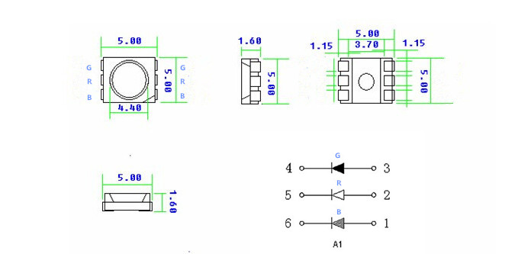
- View Angle:
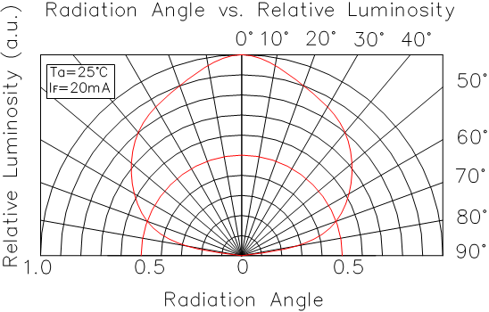
Absolute Maximum Ratings (Ta = 25℃)

Items项目 | Symbol符号 | Absolute maximum Rating | Unit
Power Dissipation | PD | 200 | mW
Forward Current(DC) | IF | 60 | mA
Peak Forward Current | IFP | 100 | mA
Reverse Voltage | VR | 5 | V
Operation Temperature | Topr | ﹣20～﹢85 | ℃
Storage Temperature | Tstg | ﹣30～﹢80 | ℃
Lead Soldering Temperature | Tsol | Max.260℃ for 5 sec Max.  (3min from the base of the epoxy bulb)

Pulse width≤0.1msec duty≤1/10

Typical Electrical & Optical Characteristics(Ta=25°)

Items | Symbol | Condition | Min | Typ | Max | Unit
Forward Voltage | VF | IF =60mA | R：2.0  G：3.0  B：3.0 | --- | R：2.2  G：3.3  B：3.3 | V
Reverse Current | IR | VR =5V | --- | --- | 10 | μA
Chromatic Coordinates | X,Y | IF =60mA | --- | --- | ---
Luminous Intensity | Iv | IF =60mA*3 | R：1800  G：2700  B：1200 | --- | R：2000 G：3000  B：1500 | mcd
View Angle | 2θ1/2 | IF =60mA | --- | 150 | --- | Deg
Dominant Wavelength | WD | IF =60mA | R:620  G:520  B:465 | --- | R:630  G:530  B:470 | nm
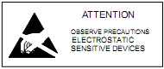 可根据客户要求订做特殊规格产品

